Visiting Card OCR Extraction System

1. Overview
The Visiting Card OCR Extraction System is a backend-based computer vision application designed to automatically extract structured contact information from visiting card images. The system takes an image of a business card as input and returns meaningful data such as name, designation, phone number, email address, website, company name, physical address, detected language, and an overall confidence score.
The project combines Optical Character Recognition (OCR), image preprocessing, and rule-based Natural Language Processing (NLP) techniques to handle real-world visiting card layouts, fonts, and image qualities. It is implemented as a RESTful API using FastAPI.

2. Objectives
• Eliminate manual data entry from visiting cards
• Extract structured contact information accurately
• Support different card layouts and fonts
• Provide confidence score for extracted data
• Design a modular and extensible system
• Operate fully offline for privacy

3. Technologies Used
Programming Language: Python 3.8+
Backend Frameworks:
• FastAPI
• Uvicorn
OCR Engines:
• Tesseract OCR (pytesseract)
• PaddleOCR
Image Processing:
• Pillow (PIL)
• OpenCV
Text Processing:
• Regex
• langdetect
• phonenumbers

4. System Architecture
The system follows a pipeline-based architecture:
Image → Preprocessing → OCR → Text Parsing → Confidence Calculation → JSON Output
1. Client uploads visiting card image
2. Image preprocessing enhances quality
3. OCR extracts raw text
4. Parsing extracts structured fields
5. Confidence score is calculated
6. JSON response is returned

5. Project Folder Structure

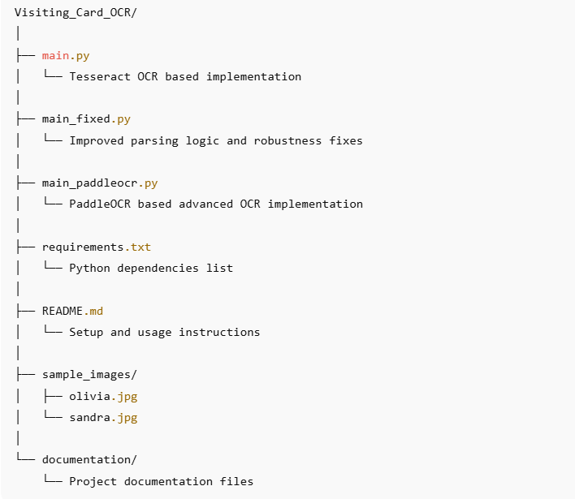

6. Installation and Setup Guidelines
Prerequisites:
• Python 3.8+
• Tesseract OCR installed locally

Steps:
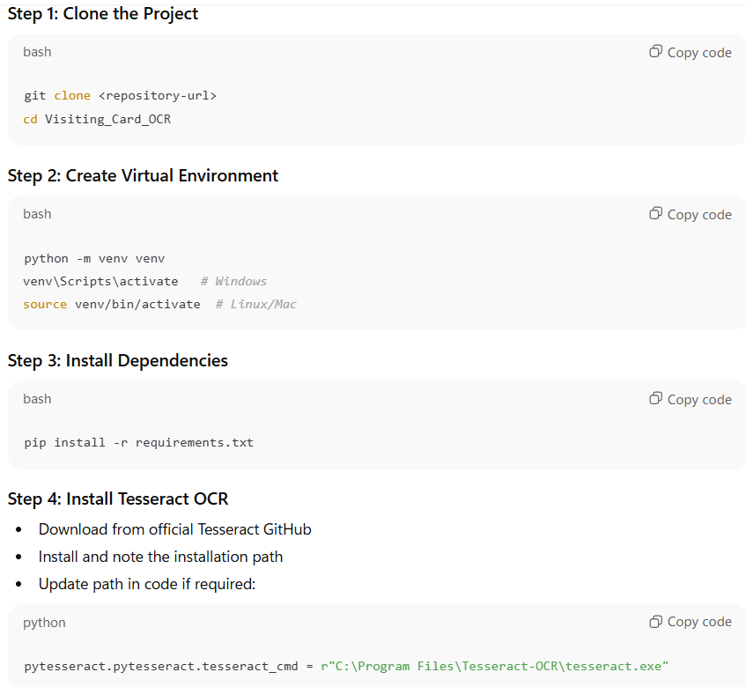

7. Running the FastAPI Server
Using Python:
python main.py
Using Uvicorn:
uvicorn main_fixed:app --reload --port 8000
API Docs:
http://127.0.0.1:8000/docs

8. API Usage and Output
Endpoint: POST /extract
Inputs:
• Image file (multipart)
• Base64 image (optional)
• OCR language (default: eng)
The API returns structured JSON containing extracted fields, detected language, confidence score, and raw OCR text.
Example working of the model:
Example Visiting Card:


Example Output (in JSON format):
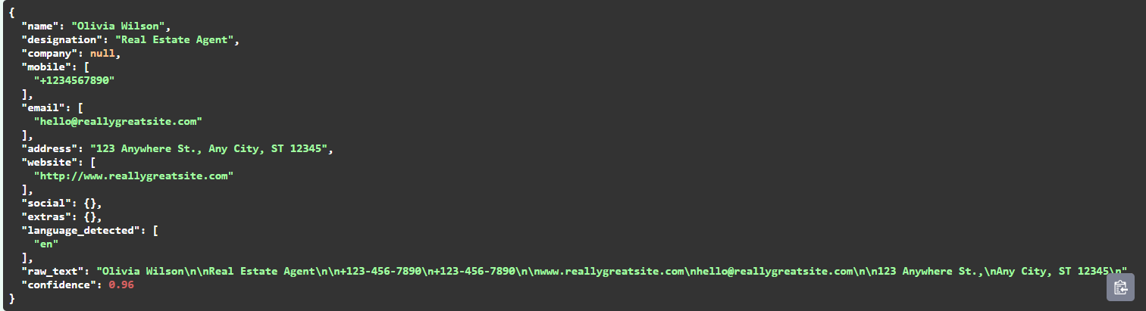

9. Developer Guidance and Improvements
Understanding the Project
- Start with main.py to understand the basic OCR pipeline
- Read ocr_from_bytes() to see how OCR is performed
- Follow parse_text() to understand text extraction logic
- Test with sample images before modifying code
Improving the Project
- Replace regex-based parsing with ML-based NER (spaCy, BERT)
- Introduce layout-aware OCR (LayoutLM, DocTR)
- Improve multilingual support
- Add database storage (PostgreSQL / MongoDB)
- Create frontend UI for uploads and review

10. Future Scope
- Mobile scanning application integration
- Real-time camera-based OCR
- CRM integration for contact storage
- Batch visiting card processing
- GPU-accelerated OCR pipelines
- Cloud deployment with scaling support

11. Real-World Effectiveness

This system can be effectively used in:

Corporate contact digitization

Sales and marketing lead management

Conference and event networking

HR onboarding processes

Document digitization platforms

Its offline capability makes it suitable for privacy-sensitive environments.

12. Conclusion
The Visiting Card OCR Extraction System successfully demonstrates how computer vision and text processing can automate a real-world problem. By combining OCR engines, intelligent preprocessing, and structured parsing, the project achieves reliable extraction of contact details from diverse visiting card designs. Its modular architecture allows easy enhancement, making it a strong foundation for both academic and industrial applications.

